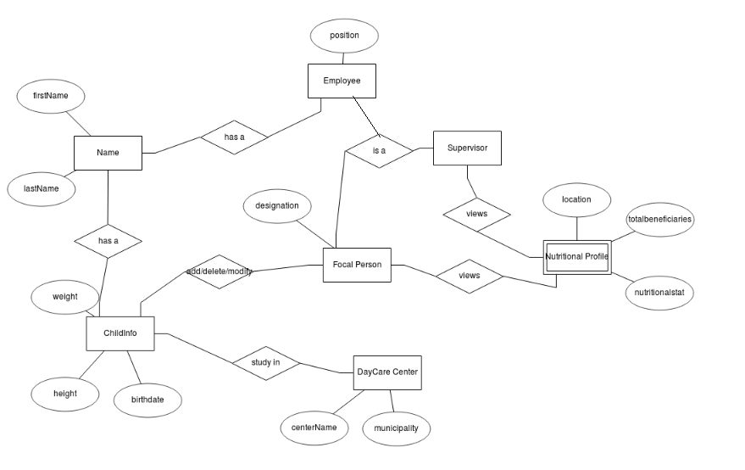
AUTOMATED ACCESS ON NUTRITIONAL STATUS

ENTITY – RELATIONSHIP DIAGRAM

